HOW TO USE NSPlayer

NSPlayer is a free and open source audio player. It is beginner friendly, free and simple. It consumes very low resources.

You can download NSPlayer from the GitHub NSPlayer Website.

NSPlayer currently comes in 4 forms:

- A Zip file for portable use. This is the standard installation
- A NSPlayer_setup.exe which installs the latest version NSPlayer automatically. This method is Recommended for Beginners.
- A NSPlayer.exe which is a stand-alone file or an executable file that can be used as a portable app. It has all the required dependencies prebuilt into it. You can just use it by clicking it
- A NSPlayer.py which is a python file that can be run on Windows, Mac and Linux. You need python and pygame installed to run this. These are not necessary to run the other three types. You can either run the setup.sh or setup.bat to install all the necessary dependencies or install them manually using “pip install pygame”
- A dmg file for Mac and appimage file for linux coming soon
- For more documentation, visit GitHub
- This project is registered under the MIT License. Check out the full doc at MIT
INSTALLATION

The Zip Installation:
- Download the zip file from Releases
- Unzip the File to any folder you want.
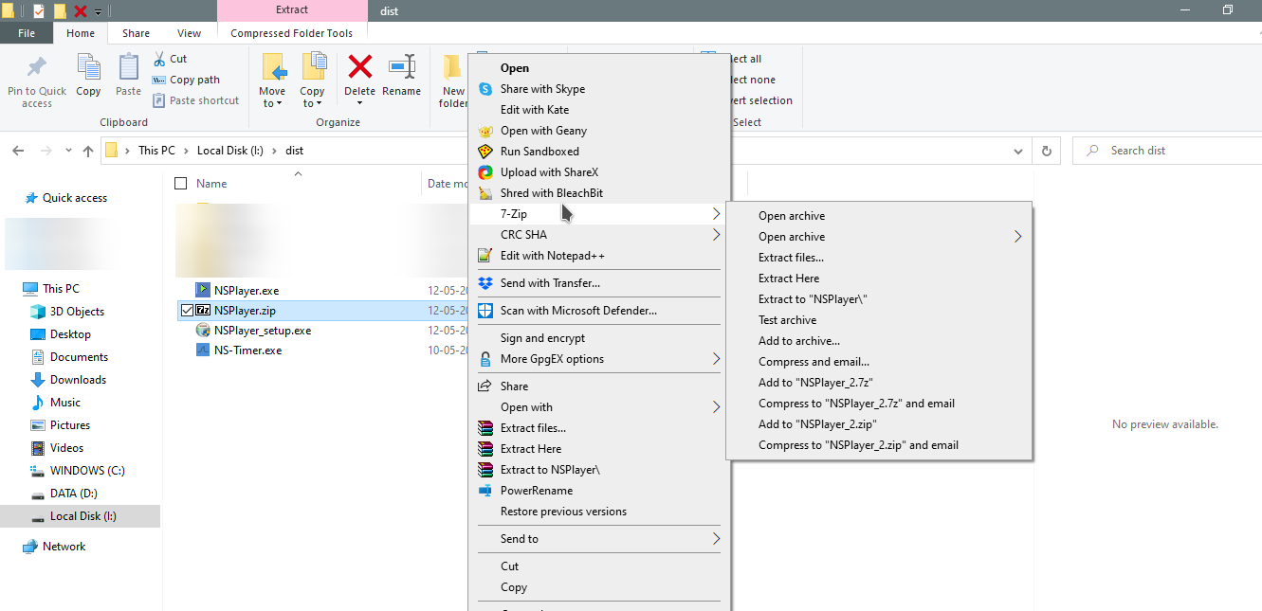
- Next, search for NSPlayer.exe and run it.
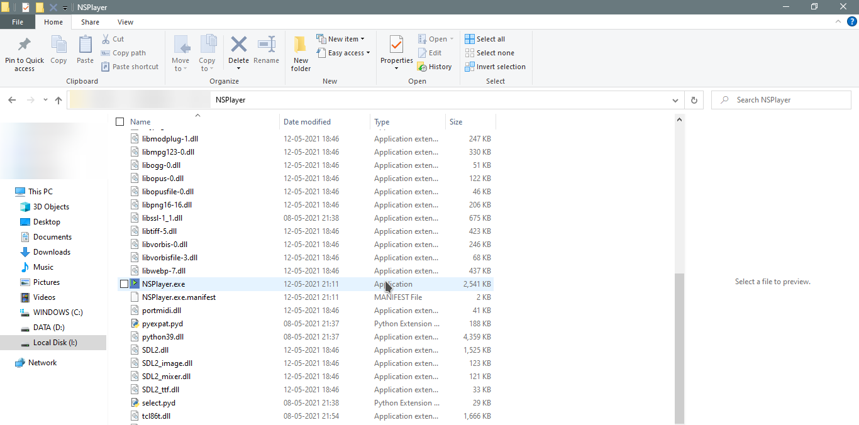
- Choose the song folder directory and enjoy

The NSPlayer_setup.exe Installation:

Just run the setup and locate the file you downloaded NSPlayer to, “C:\Program Files\NSPlayer” by default, the follow the instructions in The Zip Installation

The NSPlayer.py

